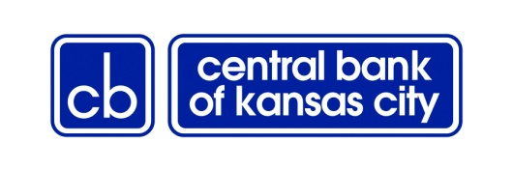
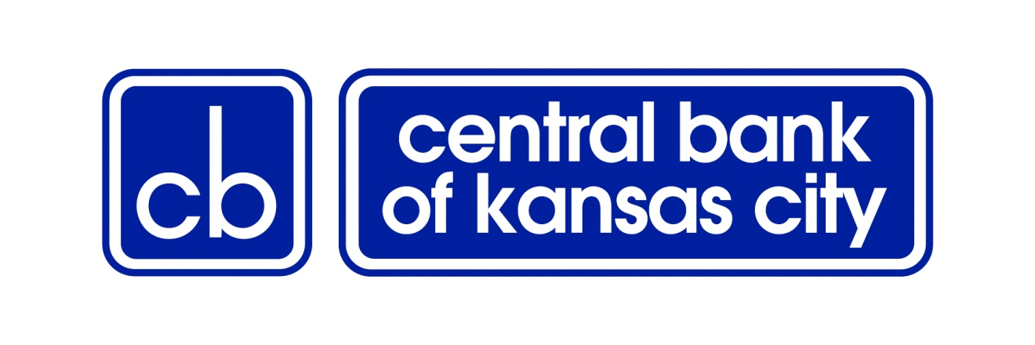
Direct Deposit Authorization

Complete each field in this form. Return the signed form along with a voided check to your employer.

Company Information
Company Name
Address
City | State | ZIP Code | Phone

Employee Information
Name |  | Employee ID # |  | SSN
Address
City | State |  | ZIP Code | Phone

Bank Information

Central Bank of KC
2301 Independence Blvd.
Kansas City, MO 64124

Routing – Transit 101001283

For any direct deposit related questions, please call 816-483-1210

Deposit Information

Account type:  Checking  Savings  Money Market

Account #
Amount $ or %

Account type:  Checking  Savings  Money Market

Account #
Amount $ or %

I authorize the above named employer to make deposits in the Central Bank of Kansas City Bank account(s) identified above and authorize the bank to accept such deposits. It is agreed that these deposits and adjustments may be made electronically and under the Rules of the National Automated Clearing House Association. I understand that this authorization replaces any previous authorization and will remain in full force and effect until the company named above has received written notification from me of its termination in time to afford the company and the depository a reasonable opportunity to act.

Employee Signature
Date

ATTACH A VOIDED CHECK FROM YOUR BANK ACCOUNT

CBKC-5-2013

